NCP LAB 2

24/07/2020

RAGUL S V – CB.EN.U4CSE17348

Q1) Nested Table

<!doctype html>

<html>

<head>

<meta charset="utf-8">

<title> NestedTables </title>

</head>

<body>

<caption title="Container Table"> Container Table </caption>

<table border="5px" bordercolor = "red">

<tr>

<td>

<table>

<tr>

<th colspan="2"> Nested Table 1 </th> </tr>

<tr> <th> Column 1 </th>

<th> Column 2 </th>

</tr>

<tr> <td> Our First Table </td>

<td> Nested Within </td> </tr>

</table>

</td>

<td>

<table >

<tr>

<th> Nested Table 2 </th>

</tr>

<tr>

<td>

<ul>

<li> List Object 1 </li>

<li> List Object 2 </li>

<li> List Object 3 </li>

</ul>

</td>

</tr>

<table>

</td>

</tr>

<tr>

<td>

<table>

<tr> <th colspan="2" align="center"> Nested Table 3 </th> </tr>

<tr><td> <a href=""> Nested Table </a> </td>

td> Demo Continued </td> </tr>

</table> </td>

<td>

<table>

<tr> <th> Nested Table 4 </th> </tr>

<tr>

<td> <img src="https://png.pngtree.com/png-clipart/20190630/original/pngtree-html-file-document-icon-png-image_4172519.jpg" height="120px" width="120px" alt="html"> </td> </tr> </table>

<td>

</tr>

</table>

</body>

</html>

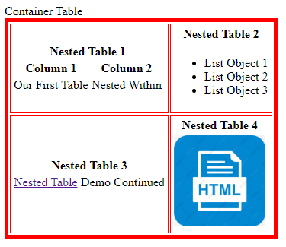

Q2)Time Table

<!doctype html>

<html>

<head>

<meta charset="utf-8">

<title> NestedTables </title>

</head>

<body>

<caption title="Container Table"> Container Table </caption>

<table border="5px" bordercolor = "red">

<tr>

<td >

<table>

<tr> <th colspan="2"> Nested Table 1 </th> </tr>

<tr> <th> Column 1 </th> <th> Column 2 </th> </tr>

<tr> <td> Our First Table </td>

<td> Nested Within </td> </tr>

</table>

</td>

<td>

<table >

<tr> <th> Nested Table 2 </th> </tr>

<tr>

<td>

<ul>

<li> List Object 1 </li>

<li> List Object 2 </li>

<li> List Object 3 </li>

</ul>

</td>

</tr>

</table> </td> </tr>

<tr>

<td>

<table>

<tr> <th colspan="2" align="center"> Nested Table 3 </th> </tr>

<tr>

<td> <a href=""> Nested Table </a> </td>

<td> Demo Continued </td> </tr>

</table> </td>

<td>

<table>

<tr> <th> Nested Table 4 </th> </tr>

<tr>

<td> <img src="https://png.pngtree.com/png-clipart/20190630/original/pngtree-html-file-document-icon-png-image_4172519.jpg" height="120px" width="120px" alt="html"> </td> </tr> </table>

</td>

</tr>

</table>

</body>

</html>

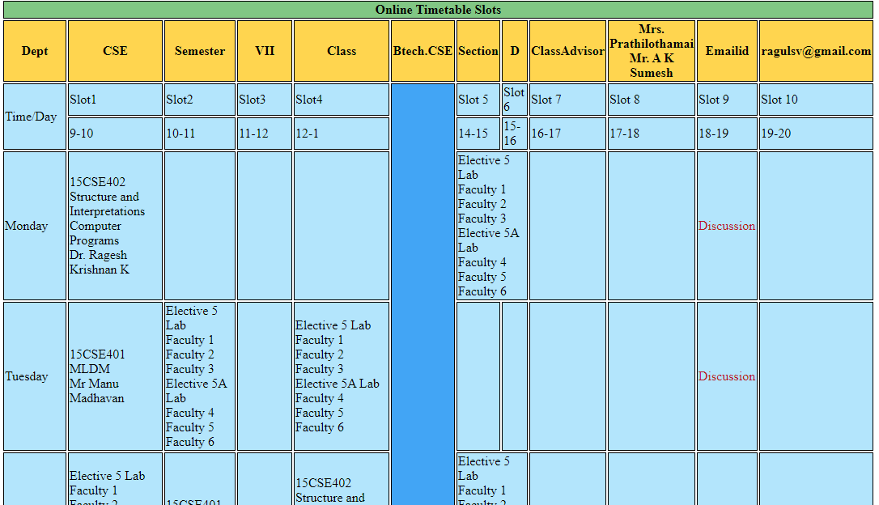

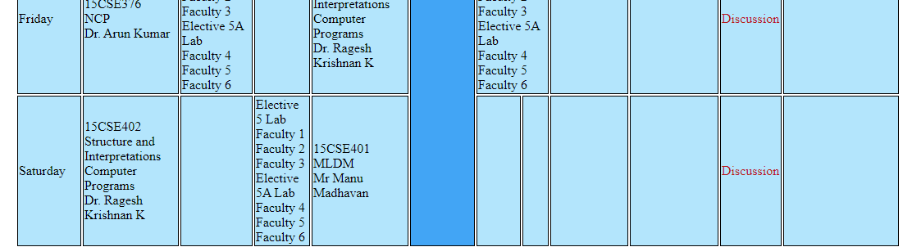

Q3) Image Map

<!DOCTYPE html>

<html>

<head>

<title>Image Map</title>

<style>

body{

padding:0px;

margin:0px;

}

</style>

</head>

<body>

<img src="computer.png" usemap="#rect">

<map name="rect">

<area shape="rectangle" coords="80,114,220,198" href="https://en.wikipedia.org/wiki/Printer_(computing)">

<area shape="rectangle" coords="260,86,440,240" href="https://en.wikipedia.org/wiki/Computer">

<area shape="rectangle" coords="450,100,580,270" href="https://simple.wikipedia.org/wiki/Central_processing_unit">

<area shape="rectangle" coords="230,250,330,320" href="https://en.wikipedia.org/wiki/Computer_speakers">

<area shape="rectangle" coords="340,270,650,300" href="https://simple.wikipedia.org/wiki/Keyboard_(computer)#:~:text=A%20computer%20keyboard%20is%20an,a%20keyboard)%20into%20a%20computer.&text=Using%20a%20keyboard%20to%20enter,%2Dbuttons%20called%20%22keys%22.">

<area shape="rectangle" coords="530,300,600,330" href="https://simple.wikipedia.org/wiki/Computer_mouse#:~:text=A%20computer%20mouse%20is%20a,in%20front%20of%20your%20computer.">

</map>

</body>

</html>

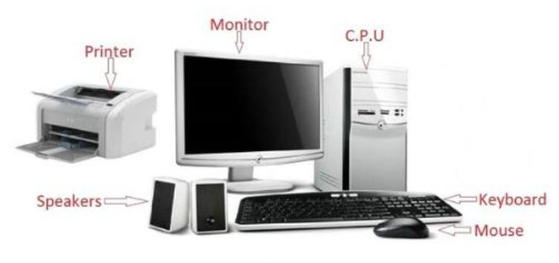 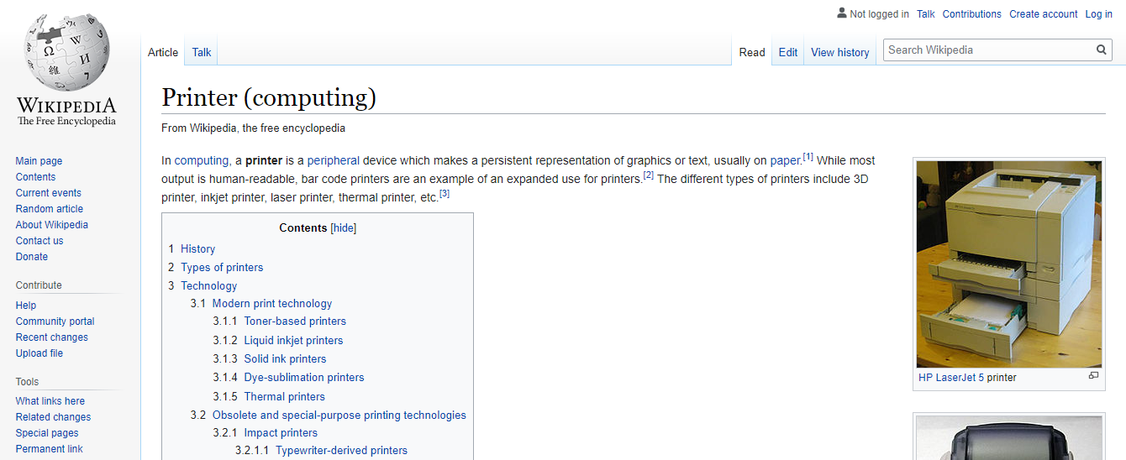 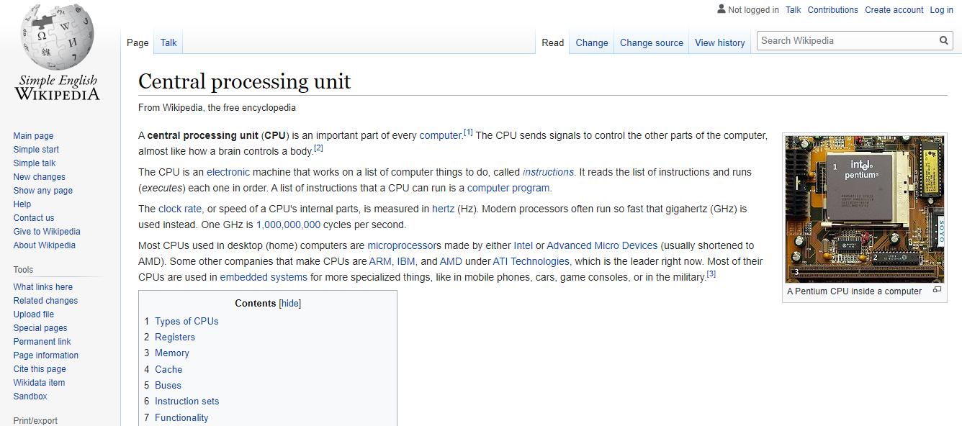

Q4) Form

<!DOCTYPE html>

<html lang="en">

<head>

<meta charset="UTF-8">

<meta name="viewport" content="width=device-width, initial-scale=1.0">

<title>Q4</title>

</head>

<style>

table,

tr,

td {

border:solid 1px black;

padding: 5px;

}

.centered {

margin:auto;

}

</style>

<body>

<div class="centered">

<form action="post">

<table>

<tr>

<td>

<label for="title">Title:</label>

<input type="text" id="title" name="title">

<label for="fname">First name:</label>

<input type="text" id="fname" name="fname">

</td>

<td>

<label for="lname">Last name:</label>

<input type="text" id="lname" name="lname"><br>

</td>

</tr>

<tr>

<td>

<label for="democar">Demo Car ID</label>

<input type="text" id="lname" name="lname">

<label for="ccnumber">Company Card no</label>

<input type="text" id="lname" name="lname">

</td>

<td>

<label for="bdate">DOB</label>

<input type="date" id="DOB" name="DOB"><br>

</td>

</tr>

<tr>

<td>

<label for="lname">Licesnse Country</label>

<input type="text" id="lname" name="lname">

<label for="lname">Issue Date</label>

<input type="date" id="lname" name="lname">

</td>

<td>

<label for="lname">IATA</label>

<input type="number" id="lname" name="lname"><br>

</td>

</tr>

<tr>

<td>

<label for="lname">Driver Licesnse no</label>

<input type="text" id="lname" name="lname">

<label for="lname">Exp Date</label>

<input type="date" id="lname" name="lname">

</td>

<td>

<label for="lname">Phone 1</label>

<input type="number" id="lname" name="lname"><br>

</td>

</tr>

<tr>

<td>

<label for="lname">Address</label>

<input type="text" id="lname" name="lname">

</td>

<td>

<label for="lname">Phone 2</label>

<input type="number" id="lname" name="lname"><br>

</td>

</tr>

<tr>

<td>

<input type="text" id="lname" name="lname">

</td>

<td>

<label for="lname">Fax</label>

<input type="number" id="lname" name="lname"><br>

</td>

</tr>

<tr>

<td>

<label for="lname">City/state</label>

<input type="text" id="lname" name="lname">

<label for="lname">Zip</label>

<input type="text" id="lname" name="lname">

<label for="lname">Country</label>

<select>

<option value="1">country 1</option>

<option value="2">country 2</option>

<option value="3">country 3</option>

</select>

</td>

<td>

<label for="lname">SMS no</label>

<input type="number" id="lname" name="lname"><br>

</td>

</tr>

<tr>

<td>

<label for="lname">Employer</label>

<input type="text" id="lname" name="lname">

<label for="lname">Customer Source Type</label>

<input type="text" id="lname" name="lname">

</td>

<td>

<label for="lname">Email</label>

<input type="email" id="lname" name="lname"><br>

</td>

</tr>

</table>

</form>

</div>

</body>

</html>

